
The KINDER study – Kidney Inequalities: Needs, Data, Experiences, Response

CODE: HIPS 23/17
RESEARCH PROJECT BRIEFING
CODE:
RESEARCH PROJECT BRIEFING
TITLE AND/OR DESCRIPTION

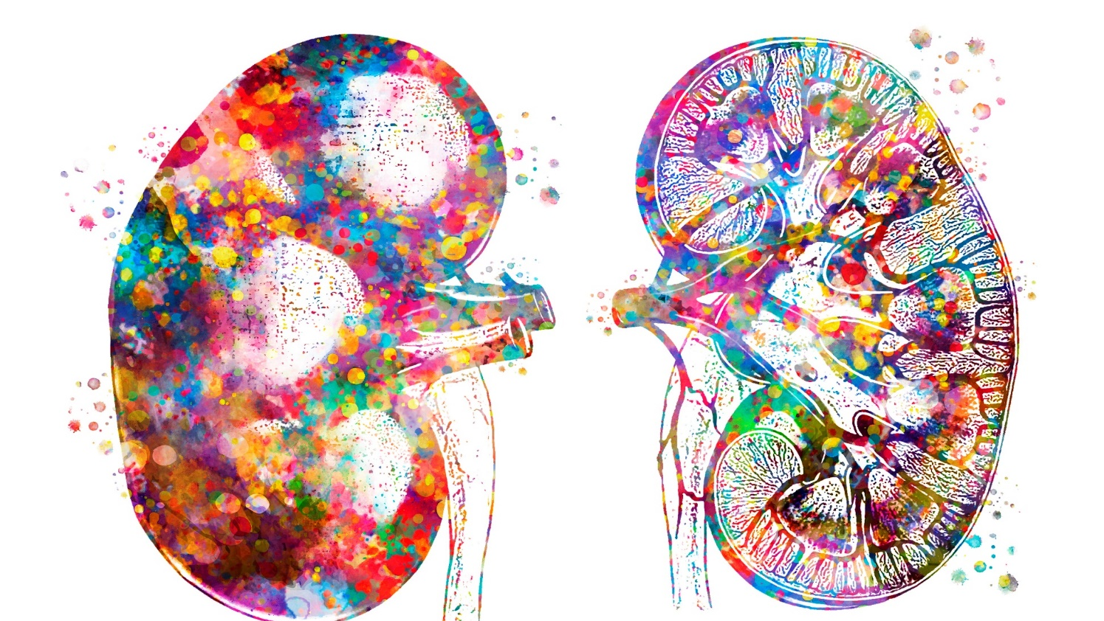
The KINDER study aimed to advance understanding of kidney healthcare inequities in Scotland - moving beyond simply recognising that disparities exist, to uncovering their causes and identifying practical strategies to reduce their impact.

The study team wished to understand how deprivation affects the diagnosis and access to early chronic kidney disease (CKD) care of people of working age and identify strategies to mitigate or reduce inequities.
Image Credit: © Valentyna Sokol
- This mixed methods study brought together innovative health data and Scottish Census linkages; patient and health professional experiences from across Scotland; and expert stakeholder workshops to identify strategies to mitigate inequities in early kidney care.

- Inequities in kidney health care and outcomes were evident across the clinical course but most pronounced at the earliest stage of kidney disease detection, among people of working age; and men. Quantitative analysis revealed intersectional disadvantages at neighbourhood, household, and individual levels. People in deprived communities were more likely to present late, missing opportunities for timely initiation of clinical course modifying treatments

- Qualitative interviews revealed that in deprived communities, early kidney care occurs late. People often discover it by accident and at an already advanced stage. With clinicians signaling low urgency, CKD rarely becomes a priority amid other pressing health and life problems. People then struggle to navigate a pressured primary-care system with limited CKD understanding, constrained resources, and uneven community biopsychosocial provision...

- Stakeholder workshops identified three priority areas for narrowing kidney inequities in Scotland from which 18 potentially feasible improvement activities were identified:
(1) improved messaging, (2) reducing practical barriers; (3) whole-person care
KEY FINDINGS
AIMS

Chief Scientist Oﬃce, St Andrews House, Regent Road, Edinburgh, EH1 3DG
www.cso.scot.nhs.uk | @CSO_Scotland
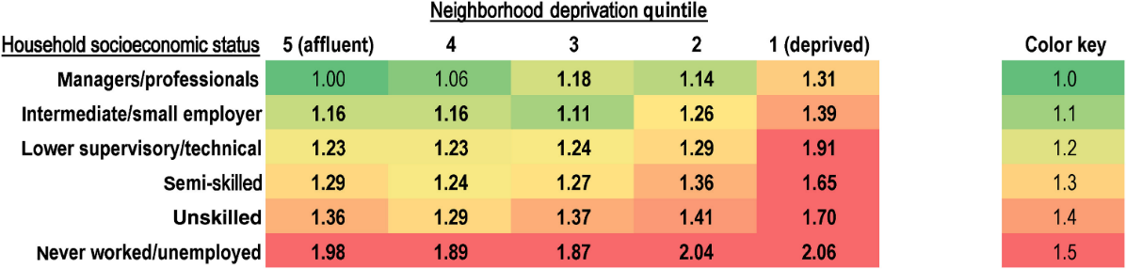
Participatory Analytic Approach
This was a mixed-methods study involving a critical realist approach to explore how and why health inequities are experienced. The study idea was initially conceived by our patient partners from Grampian Kidney Patient Association. Each element of study design was developed with deliberations between qualitative and quantitative analysts, study leads (primary care, nephrology, and counselling practitioners), methods experts, clinical stakeholders, and public and patient partners. Results were interpreted using qualitative insights from patients and primary care professionals to understand social contexts and potential mechanisms.

WP1 - Quantitative
We conducted a groundbreaking linkage of health and social data for 80,000 people newly presenting with kidney disease in Scotland over a ten-year period. By linking health records to the 2011 and 2022 Scottish Censuses, the study examined how socioeconomic deprivation affected diagnosis, self-reported health, access to care, and health outcomes.

WP2 - Qualitative
We interviewed 38 working-age adults with kidney disease from deprived urban and rural communities across Scotland and held focus groups with 23 primary care professionals in disadvantaged areas to explore experiences and challenges in early-stage kidney care.

WP3 - Workshops
We organised a series of workshops with a wide range of professional groups from Scotland and England, including NHS Education for Scotland education leads, general practitioners, public health specialists, social prescribing services, nurses, pharmacists, and patients. The process identified seven improvement opportunities for issues affecting early kidney care, drawn from quantitative data, interviews and focus groups. These were consolidated into three overarching themes, with 18 specific activities to address them.
WHAT WERE THE RESULTS AND WHAT DO THEY MEAN?
WP1 Quantitative: Consequences of socioeconomic deprivation for early kidney care
We developed a kidney data algorithm that would minimise ascertainment biases and avoid missing the most underserved people we were most interested in analysing, yet least visible. With this approach, we found that both deprived households and neighbourhoods were independently associated with greater mortality risk: up to two-fold for people in both deprived households and deprived neighbourhoods (figure below). Deprived households also more frequently faced additional risks to health outcomes of adverse mental health, living alone, basic accommodation, lack of car, language, visual and hearing difficulties.

WHAT DID THE STUDY INVOLVE?
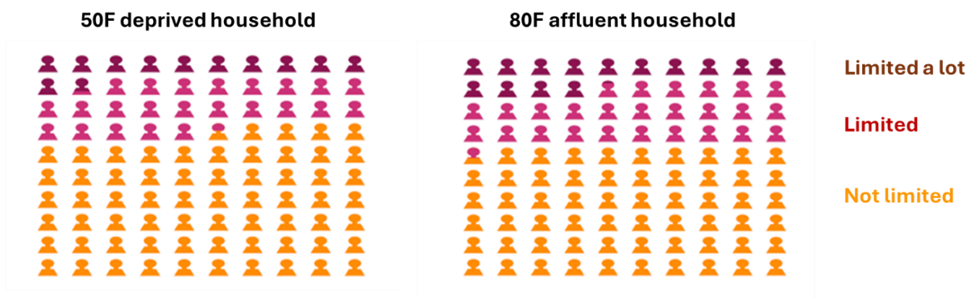
We systematically assessed the key domains of early care and identified the greatest gaps between deprived and affluent communities were in (1) timeliness of presentation and (2) care navigation to avoid need for unscheduled care. Deprivation was associated with twofold odds of presenting late, leading to worse health outcomes. This resonates with our qualitative findings of difficulties faced in candidacy for early kidney care. Even at the earliest stages people in deprived households also reported greater limitation in daily life. Accounting for case-mix differences, our models projected that a 50-year-old female in a deprived household would have similar daily life limitations to an 80-year-old in an affluent household (figure below).

WP2 Qualitative: Candidacy for early kidney care amid biopsychosocial disadvantage
38 patient and 23 primary care health professional participants were drawn from the most deprived areas of Scottish health boards. Data were analysed using reflexive thematic analysis, with codes inductively mapped onto the Candidacy Framework. We found that early kidney care for working-age adults in deprived communities was often delayed. Kidney disease, within the cardiovascular-kidney-metabolic syndrome, was detected late with patients’ resources - time, money, and support - already stretched. Diagnosis was typically explained briefly, if explained at all, leading to uncertainty about its significance and next steps. We found communication and care to vary widely, with many patients relying on personal persistence to navigate fragmented healthcare systems. One patient reflected “They are nae worrying about it… so what’s the point in asking?” Care was reported to rely on professional discretion to go above and beyond and bridge gaps in care. These findings highlight how structural factors and limited support systems hinder timely and consistent kidney care.

WP3 Workshops: Co-designing solutions for early entry points to kidney care
The workshops identified seven improvement opportunities for issues affecting early kidney care, drawn from quantitative data, interviews and focus groups. These were consolidated into three priority themes (illustrated overleaf). Participants identified the greatest potential to reduce inequities at early entry points through community-based settings and cross-sector delivery. Target clinical settings could include co-location of services within hubs, pop-in clinics, and routine touchpoints such as annual health checks to incorporate kidney health. The three priority themes are listed below and expanded improvement opportunities in the figure:

(1) Improve kidney health messaging that is trusted, consistent, and usable by patients
(2) Reduce the practical barriers to early access to care
(3) Whole-person care, including lay support, social prescribing, and resourced counselling

Trusted, consistent messaging was important for those having initial discussions about CKD, including pharmacists and practice nurses. This would benefit from support from peers and social prescribing services acting as navigators, delivered in genuine, predictable ways embedded in the NHS pathway. Reducing access barriers centred on improving primary care appointment flexibility and coordinated support. Participants emphasised the importance of introducing early mental health interventions in chronic kidney disease, highlighting professional psychological support and peer-based relational support as key to sustaining wellbeing and life participation.

Stakeholders developed 18 specific activities that could feasibly be implemented in a targeted or proportionate manner to mitigate inequities. They stressed a need to support primary care staff, through training in kidney health and relational whole-person communication, alongside accessible digital tools.

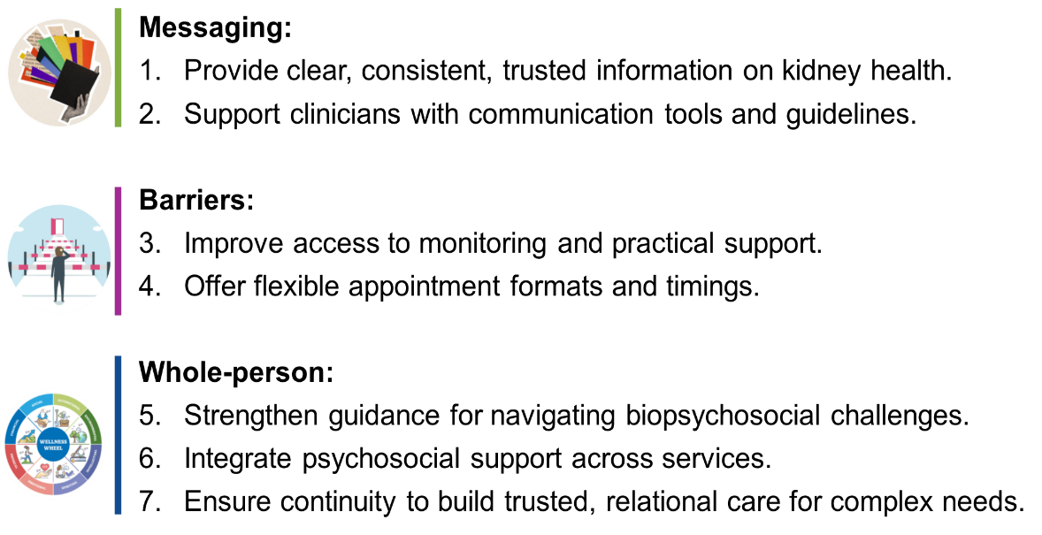

The KINDER study comes at a critical time as Scotland responds to evidence from an independent review into health inequalities, has a life expectancy falling further behind the rest of Europe, and develops a new Long Term Conditions Framework to cut across long term conditions including kidney disease. Beyond Scotland, the kidney community is increasingly aware of the potential of inequitable organisation of care as health services act to rapidly implement prescription of new “game changing” treatments for kidney disease. KINDER highlights constraints within current community care models that limit the ability to deliver flexible, holistic, equitable care at the earliest and most treatable stages of kidney disease.

A PPI partner commented during the study: “I think that’s great - it really brings the research to life, which is brilliant. I’d be confident in it as well, even though it’s not directly comparable to other kidney-related research, because it’s quite pioneering in that sense. From my experience with grants and projects focused on deprivation and priority neighbourhoods, a lot of what you're describing resonates. It makes you think about how deep the impact of poverty runs across all areas of life, especially for those with chronic illnesses. Even beyond kidney care, this kind of research aligns with broader community planning and health priorities, particularly here in Aberdeen. It speaks to the real and wide-reaching impact of poverty, and I think it adds significant value, not just for the kidney community but in shaping wider policies on inequality. Our conversation really highlights the importance of this kind of work. It shows just how valuable and timely the research is.”

Improvement opportunities of high importance to patients in the study included improving the consistency of messaging, and embedding psychosocial support early in the kidney care pathway. The research team is part of a kidney working group informing the Scottish Government for the long-term conditions framework and presented the key findings of the KINDER study to the Cabinet Secretary for Health and Social Care at a Cross Parliamentary CKD Summit. This has helped to ensure that the specific needs of those with kidney disease have been understood by policymakers. The KINDER research team includes a Counselling Psychologist and Psychotherapist who is working with the policy lead for Kidney Research UK to consider available funding routes to design tailored and resourced psychosocial interventions to support people living with early kidney disease.

Kidney disease also represents an exemplar condition for the need to improve currently inequitable models of care cutting across cardiovascular-kidney-metabolic conditions – as highlighted by a Presidential Advisory from the American Heart Association.
WHAT IMPACT COULD THE FINDINGS HAVE?

Qualitative: Candidacy for early kidney care amid biopsychosocial disadvantage
38 patient and 23 primary care health professional participants were drawn from the most deprived areas of Scottish health boards. Data were analysed using reflexive thematic analysis, with codes inductively mapped onto the Candidacy Framework. We found that early kidney care for working-age adults in deprived communities is often delayed. Kidney disease, within the cardiovascular-kidney-metabolic syndrome, is detected late with patients’ resources - time, money, and support - already stretched. Diagnosis is typically explained briefly, if explained at all, leading to uncertainty about its significance and next steps. We found communication and care to vary widely, with many patients relying on personal persistence to navigate fragmented healthcare systems. One patient reflected “They are nae worrying about it… what’s the point in asking?” Care was reported to rely on professional discretion to go above and beyond and bridge gaps in care. These findings highlight how structural factors and limited support systems hinder timely and consistent kidney care.

Workshops: Co-designing solutions for early entry points to kidney care
The workshops identified seven improvement opportunities for issues affecting early kidney care, drawn from quantitative data, interviews and focus groups. These were consolidated into three priority themes (illustrated below), with 18 specific activities to address them. Participants identified the greatest potential to reduce inequities at early entry points through community-based settings and cross-sector delivery. Target settings involved service co-location in hubs, pop-in clinics, and routine touchpoints such as annual health checks. The three priority themes are listed below and expanded improvement opportunities in the figure:
(1) Improve kidney health messaging that is trusted, consistent, and usable by patients;
(2) Reduce the practical barriers to early access to care;
(3) Whole-person care, including lay support, social prescribing, and resourced counselling.
Trusted, consistent messaging was important for those having initial discussions about CKD, including pharmacists and practice nurses. This would benefit from support from peers and social prescribing services acting as navigators, delivered in genuine, predictable ways embedded in the NHS pathway. Reducing access barriers centred on improving primary care appointment flexibility and coordinated support. Participants emphasised the importance of introducing early mental health interventions in chronic kidney disease, highlighting professional psychological support and peer-based relational support as key to sustaining wellbeing and life participation.

Three priority areas with seven improvement opportunities to address inequities in
kidney care in Scotland
Inequities in care for people living with kidney disease in Scotland are substantial, most evidence in the early stages of disease, associated with overlapping sources of social disadvantage, and most evident among people of work ages. The consequences include increased mortality, worse kidney outcomes, greater limitations in day-to-day life.

People from deprived communities report uncertainty and mixed messaging about the meaning of kidney disease. They first present late amid competing life circumstances, and experience practical barriers to navigating and accessing fragmented care, including a lack of psychosocial support. With stakeholders we identified improvement activities that are proportionate or target underserved communities. They were considered feasible, with potential to mitigate inequities if implemented.

Implication: Early, equitable CKD care in deprived communities may be more achievable when embedded within cardiovascular-metabolic pathways and delivered through community-linked primary care, achieved through a series of incremental improvements. Our findings identify specific, equitable, and doable actions to support those improvements.
The study investigators have presented findings from KINDER at invited lectures to the Brazilian Society of Nephrology (2024); the Scottish Kidney Federation (2024) (for patients and public); a global workshop on implementation of early kidney care organised by Kidney Diseases Improving Global Outcomes (KDIGO) (2024); the World Congress of Nephrology (2025); the annual Roy and Vi Baay Chair guest lecture of University of Calgary (2025); a National Research Scotland diabetes/renal research event (2025); and UK Kidney Association Kidney Week (2025).

An invited lecture about the KINDER study to the Royal Society of Medicine (2025) provided an opportunity to highlight the value mixed-methods research linking health and social care data in Scotland together with experiences of patients and stakeholders to address underserved communities and traditional data “blind spots”.

Two quantitative abstracts were presented at the Scottish Renal Association in 2024, and a further abstract covering the workshops was presented in 2025. Two quantitative papers have been accepted for publication in Kidney International and Clinical Kidney Journal. A further quantitative paper, and two qualitative papers are currently being finalised.

The study team are represented within a Scottish Kidney working group informing the Scottish Government. We are very grateful for the regular contact we have had with Kidney Research UK, Kidney Care UK, and the UK Kidney Association to ensure that findings can be used to inform models of care within the Scottish and UK kidney communities, and to work towards directions raised by this research.

CONCLUSION
HOW WILL THE OUTCOMES BE DISSEMINATED?
Additional Information
Project dates: 1 Mar 2024 – 31 Aug 2025
Funding: £298,947.93
simon.sawhney@abdn.ac.uk
magdalena.rzewuska@abdn.ac.uk

Dr Simon Sawhney, Dr Magda Rzewuska Diaz
Prof Tom Blakeman, Mrs Audrey Hughes
The Universities of Aberdeen and Manchester
RESEARCH TEAM & CONTACT
Chief Scientist Oﬃce, St Andrews House, Regent Road, Edinburgh, EH1 3DG
www.cso.scot.nhs.uk | @CSO_Scotland

